

**LAB # 2**

**SUBMITTED BY:** Kulsoom Khurshid

**REGISTRATION #:** SP20-BCS-044

**COURSE:** Data Communication and network

**SUBMITTED TO:** DR. Mariam Akbar

**Lab Activities:**

**Activity 1:**

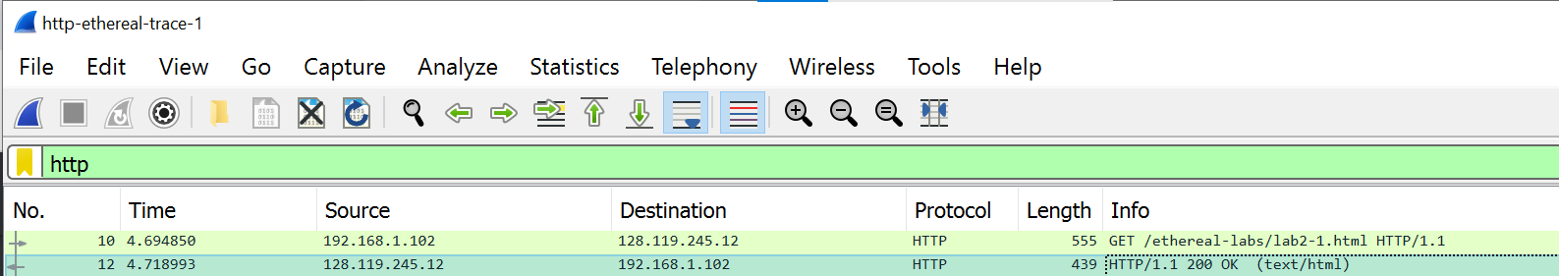

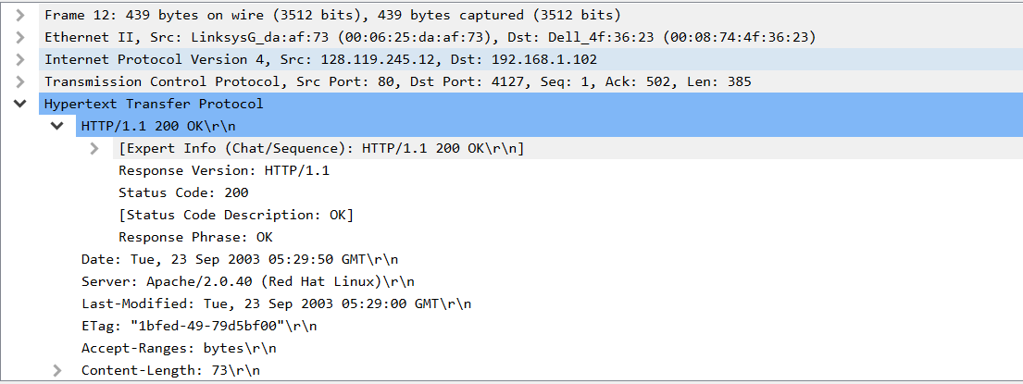

1. Is your browser running HTTP version 1.0 or 1.1? What version of HTTP is the server running?

**Ans:** HTTP 1.1

1. What languages (if any) does your browser indicate that it can accept to the server?

**Ans:** en-US (US English)

1. What is the IP address of your computer? Of the gaia.cs.umass.edu server?

**Ans:** Source IP address is 192.168.1.102

Destination IP address is 128.119.245.12

1. What is the status code returned from the server to your browser?

**Ans:** 200 OK

1. When the HTML file that you are retrieving was last modified at the server?

**Ans:** 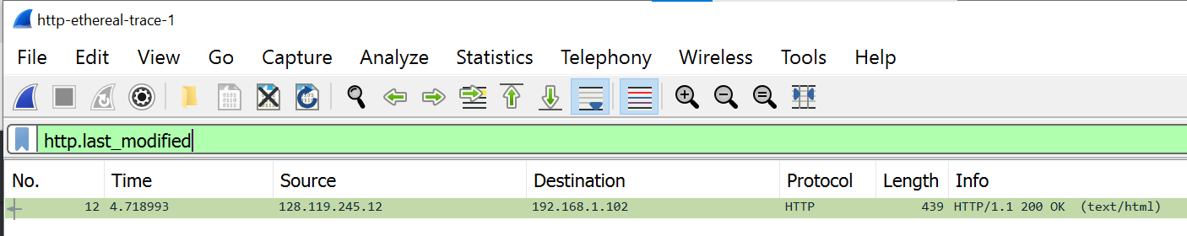

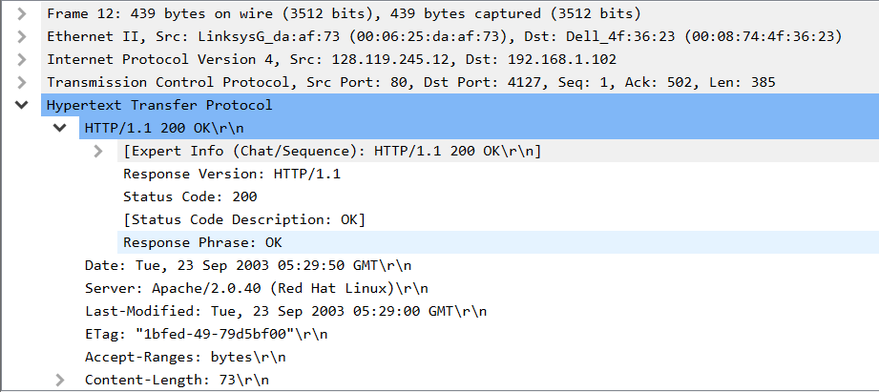

Last modified: 23, Sep 2003

1. How many bytes of content are being returned to your browser?

**Ans:** Content-length: 73 bytes

1. By inspecting the raw data in the packet content window, do you see any headers within the data that are not displayed in the packet-listing window? If so, name one.

**Ans:** The raw data appears to match up exactly with what is shown in the packet-listing window.

**Activity 2:**

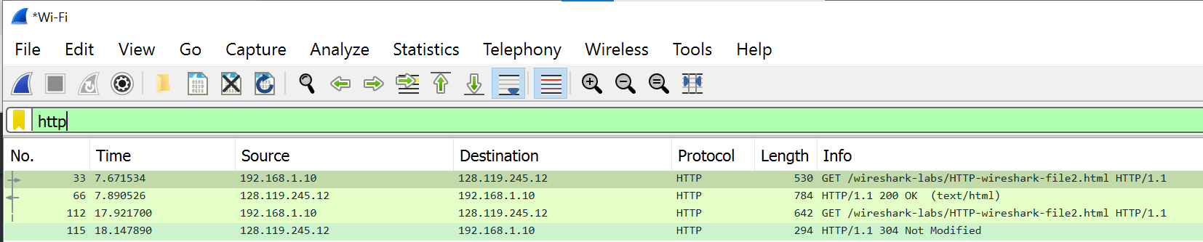

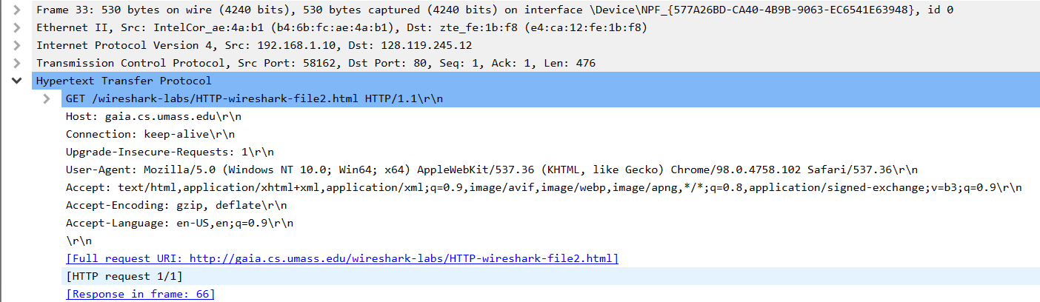

1. Inspect the contents of the first HTTP GET request from your browser to the server. Do you see an “IF-MODIFIED-SINCE” line in the HTTP GET?

**Ans:** No

1. Inspect the contents of the server response. Did the server explicitly return the contents of the file? How can you tell?

**Ans:** 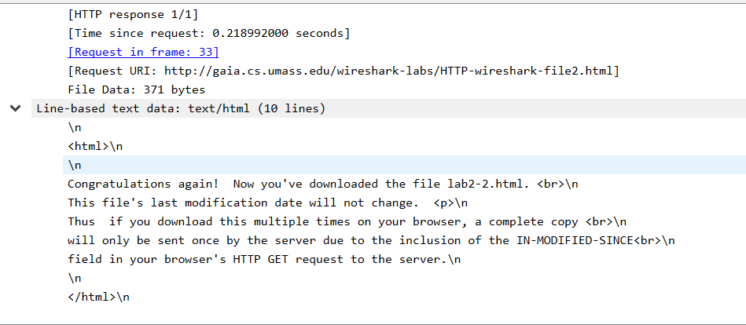

1. Now inspect the contents of the second HTTP GET request from your browser to the server. Do you see an “IF-MODIFIED-SINCE:” line in the HTTP GET? If so, what information follows the “IFMODIFIED-SINCE:” header?

**Ans:** Yes



1. What is the HTTP status code and phrase returned from the server in response to this second HTTP GET? Did the server explicitly return the contents of the file? Explain.

**Ans:** We get a HTTP/1.1 304 Not Modified Response. This is much shorter than the full response packet seen previously in part 9.

**Activity 3:**

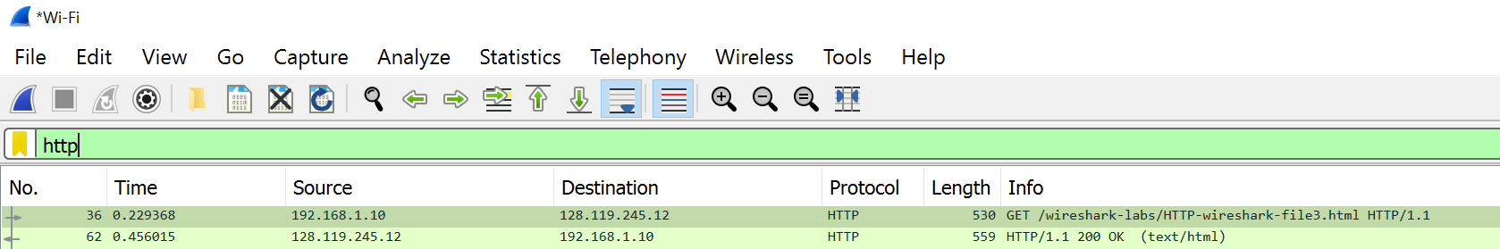

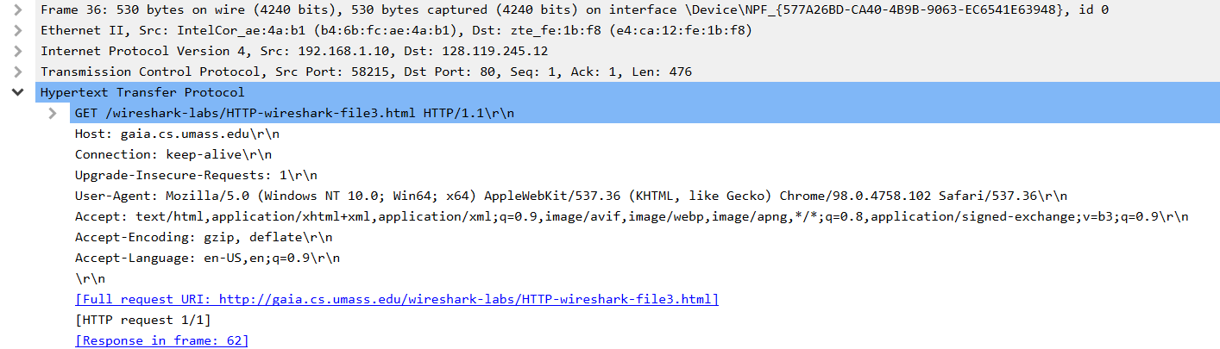

1. How many HTTP GET request messages did your browser send? Which packet number in the trace contains the GET message for the Bill or Rights?

**Ans:** Only 1 HTTP GET request message

**Packet# 36**

1. Which packet number in the trace contains the status code and phrase associated with the response to the HTTP GET request?

**Ans:** **Packet# 62**

1. What is the status code and phrase in the response? How many data-containing TCP segments were needed to carry the single HTTP response and the text of the Bill of Rights?

**Ans:** Status code is 200 OK

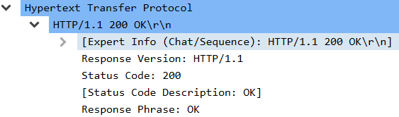

There are 4 TCP segments.

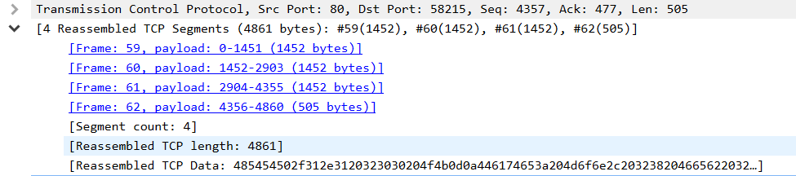

**Activity 4:**

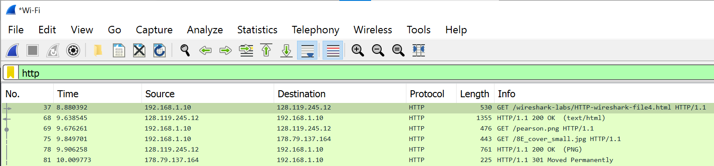

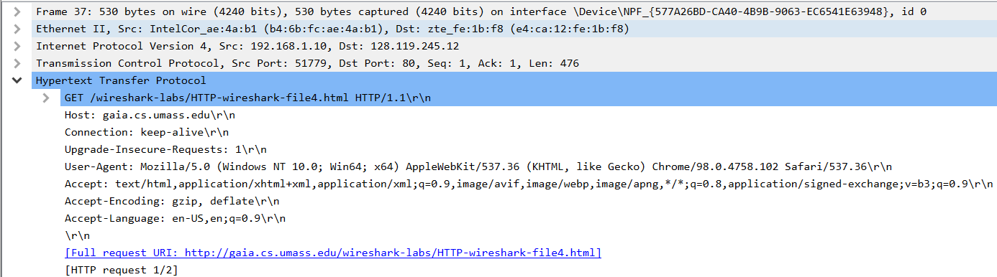

1. How many HTTP GET request messages did your browser send? To which Internet addresses were these GET requests sent?

**Ans:** We have 3 HTTP GET request message 128.119.245.12, 128.119.245.12 and 178.79.137.164

1. Can you tell whether your browser downloaded the two images serially, or whether they were downloaded from the two web sites in parallel? Explain.

**Ans:** Based on the timestamps, it appears the images were downloaded serially. Also, the source port is incrementing each time from 51779 and 51780 which means that the images were received serially over separate TCP connections.

**Home Activities:**

**Activity 1:**

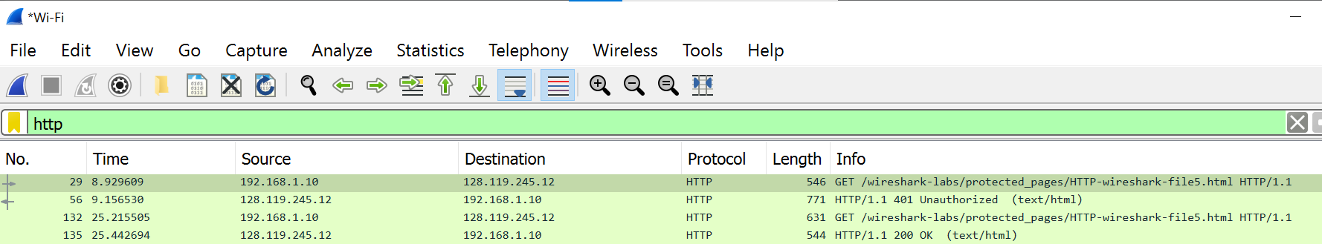

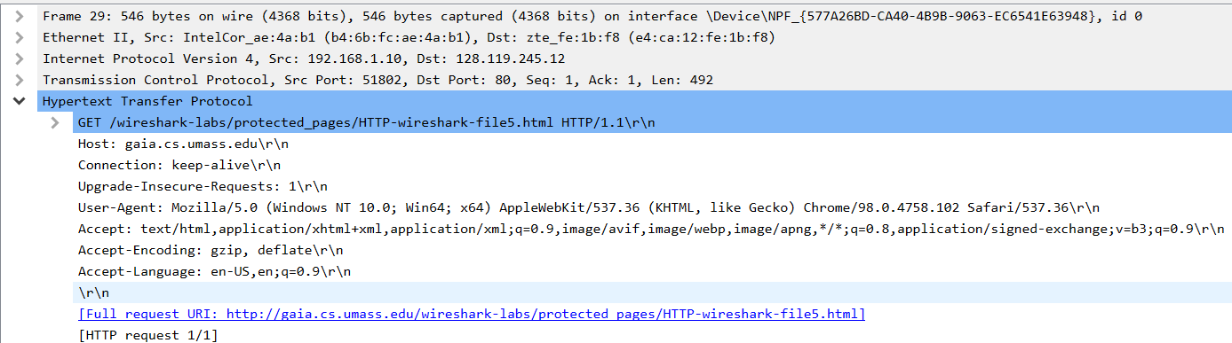

1. What is the server’s response (status code and phrase) in response to the initial HTTP GET message from your browser?

**Ans:** 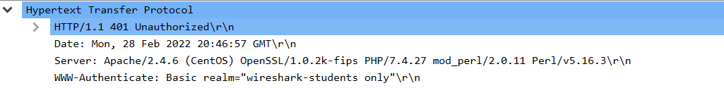

Status code: 401

Phrase: Unauthorized

1. When your browser’s sends the HTTP GET message for the second time, what new field is included in the HTTP GET message?

**Ans:** 